Date Picker Options in Dashboard Designer
***Key Points***
Dashboard chart with date picker filter using apply button:
- Below screen shot show the dashboard with date picker filter.
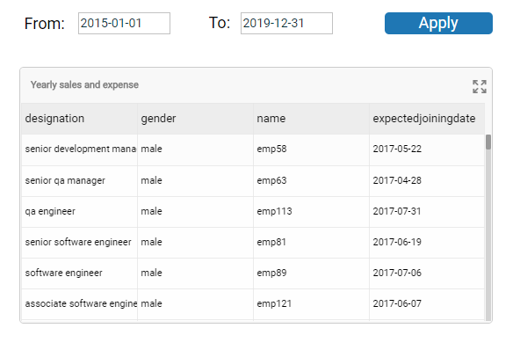
- We will use two date picker components to form from & to date option for selecting a Date Range.
- Date Picker Component: We have used two date picker component and we used first component to select start date. (From Date). In condition of connection we have passed this From Date value as parameter to date field. And second date picker component is used to select end date. (To Date) In condition of connection we have passed this To Date value as parameter to date field. And importantly we have to set the date format in properties section similar to date format in data. The standard ISO date format is ‘’YYYY-MM-DD’’.
- Label Component: Here we have used label component to resemble as apply button to see the result between these two dates. Here we have used a script. Our connection was Date_data[C_1] so we have reloaded this connection to see the changes of selected dates in action using script sdk.reload( [ 'C_1' ] );. Check below .
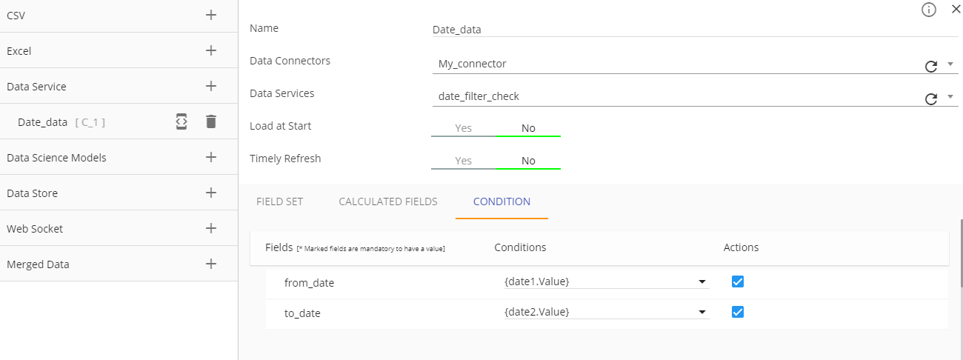
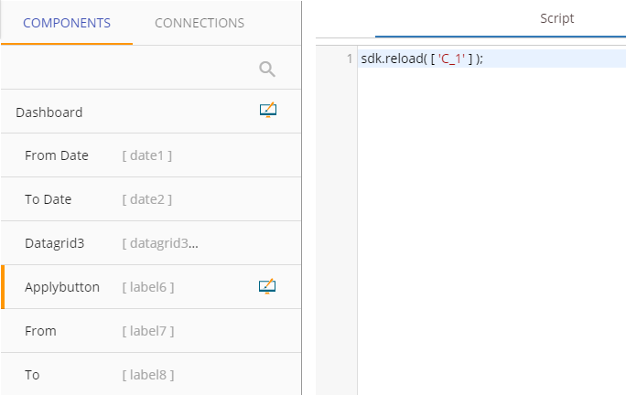
Fig. Parameter Passing

Fig. Apply Button Script

- Chart Component: This is a data grid component is used as chart component which we have used to show actual data and on the top of this we have used date filter. The data is loaded from Date_data[C_1] inside data grid and which gets filtered by selecting date.
- Then we have Save this dashboard with filename date_picker_sample1.bvzx.
Dashboard chart with date picker filter without using apply button:
- The dashboard with date picker filter we have created without using apply button here is like this:
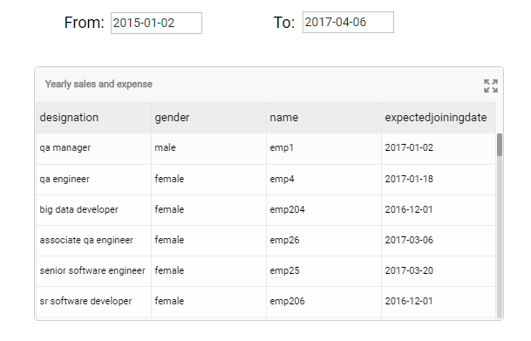
- We will use two date picker components to form from & to date option for selecting a date Range.
- Data Picker Component: We have used date picker component and we used first component to select start date. (From Date). In condition of connection we have passed this From Date value as parameter to date field. Here we have used a script. Our connection was Date_data[C_1] so we have reloaded this connection to see the changes of selected dates in action using script sdk.reload( [ 'C_1' ] );
Here is another date picker which is used to select end date. (To Date) In condition of connection we have passed this To Date value as parameter to date field. Here also we have used script sdk.reload( [ 'C_1' ] ); to load changes in data grid. . And importantly we have to set the date format in properties section similar to date format in data. The standard ISO date format is ‘’YYYY-MM-DD’’.

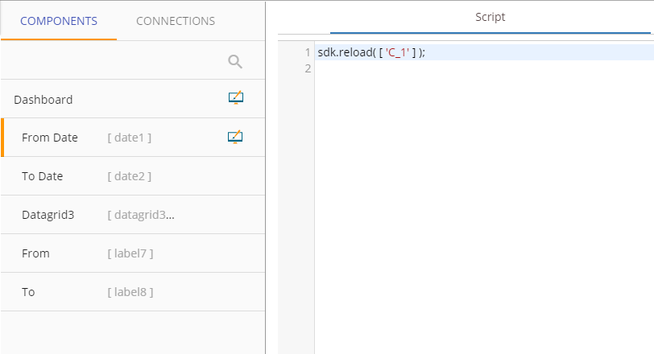
Fig. Date Component Script
- Chart Component: This is a data grid component used as chart component to show actual data and on the top of this we have used date filter. The data is loaded from Date_data[C_1] inside data grid and which gets filtered by selecting date.
- Then we have Save this dashboard with filename date_picker_sample2.bvzx.

