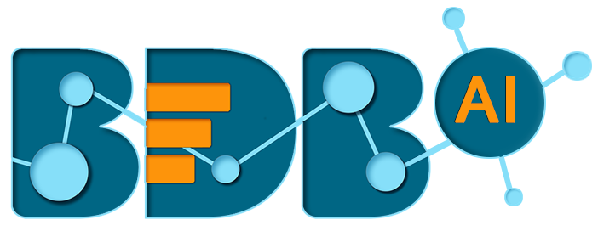
AI, Data Science & Advanced Analytics Platform
Unique Disruptive Platform by Ex-SAP BO R&D Team
One Platform, End to End Solution
Removes industry pain points
Leads to exponential benefits realization

BDB Data Center –
High Level Introduction

BDB Data Centre-
BDB Data Centre modules is a core module of platform which address data ingestion activities & has features to extract data and create data service & data store for further data analysis.
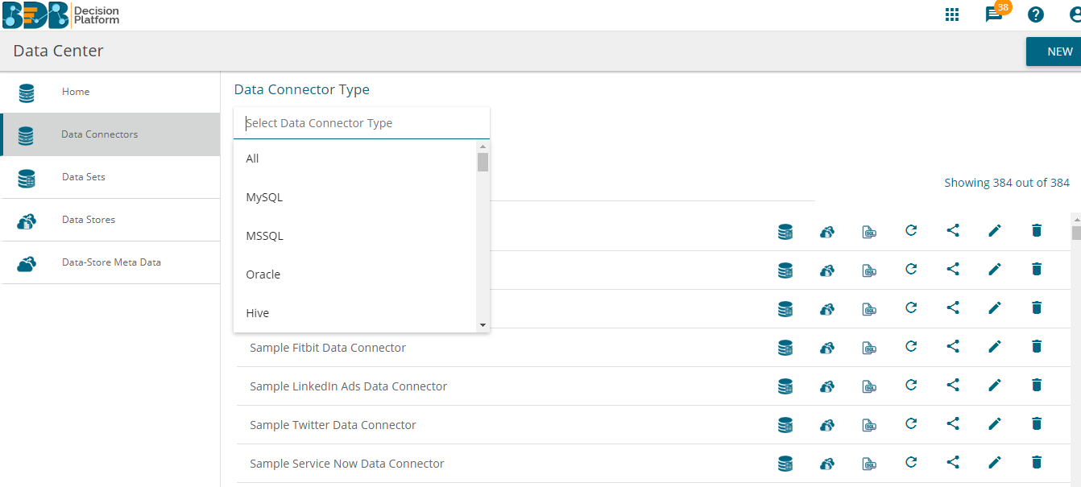

High-Level Feature Summary of BDB Data Centre
- Connect with variety of data source through Pre-built Data Connectors be it standard data warehouse, social media platform, CRM application, third party APIs etc.
- Share, Edit & Remove Data Connector Anytime
- Build data sets on top of data connector through basic SQL kind of query
- Publish data sets as web service for easy data ingestion in other modules for example to use it as an input in data viz module (BDB dashboard designer), Predictive, data cleansing (BDB ETL). Generate Xml code for debugging purpose.
- Share, Edit & Remove Data Set/Services Anytime.
- Create data store & data store meta data on elastic, provide drill hierarchy, user restrictions & create instant visualizations.

Deep-Dive into Features
BDB Data Centre Consist of –

Data Connectors
Pre-built Data Connectors to connect with variety of data sources.

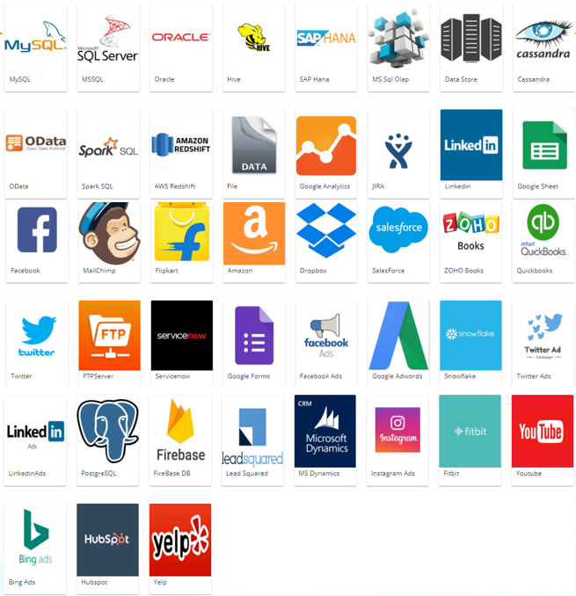

Data Set
This option lets you create a data set using parametrized SQL queries or API calls. Once a data set is created, it can be published as REST API service which can be consumed in various other BDB modules or outside the platform.

Data Store
This option lets you import data from external data source inside BDB platform using SQL queries or API calls. BDB Data Store uses Elastic Search for data interaction to use in data visualization layer (BDB Business Story module).
BDB Data Sore can be structured in desired way, as in dimensions, measures which will be used in creating visualizations can be defined, hierarchy & user restriction can be set up which will be reflected in business story.

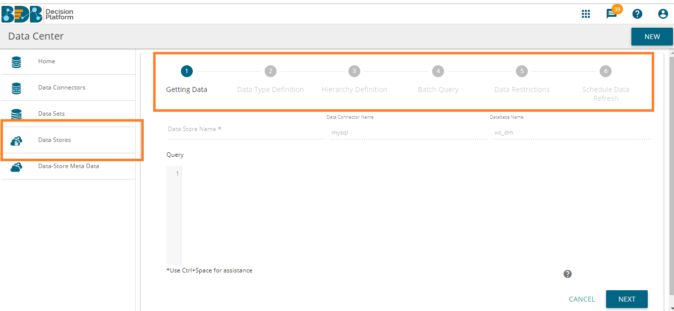

Data Store Meta Data
This option lets you import data from external data source without importing data into data store of BDB platform. It is basically a database which has a structure/ index in which the actual data can be saved/ written using BDB’s ETL.
