Can you please let us know the steps to create the below CONDITION?
Because in the ‘Field Set’, I couldn’t see the below two field names (from_date, to_date).
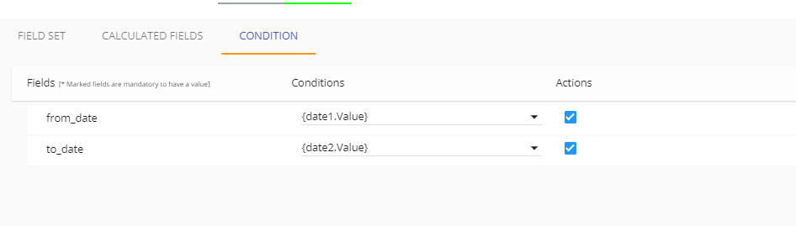

FIELD SET:

