Pipeline Testing

- The pipeline testing helps the developers to create a unit test for every component on the pipeline. We can upload input data and expected output data for every test case this will be then compared with the actual output generated by the component.

- Steps to test a Pipeline:

STEP I : Click on the Pipeline testing logo which will land you to the following page.
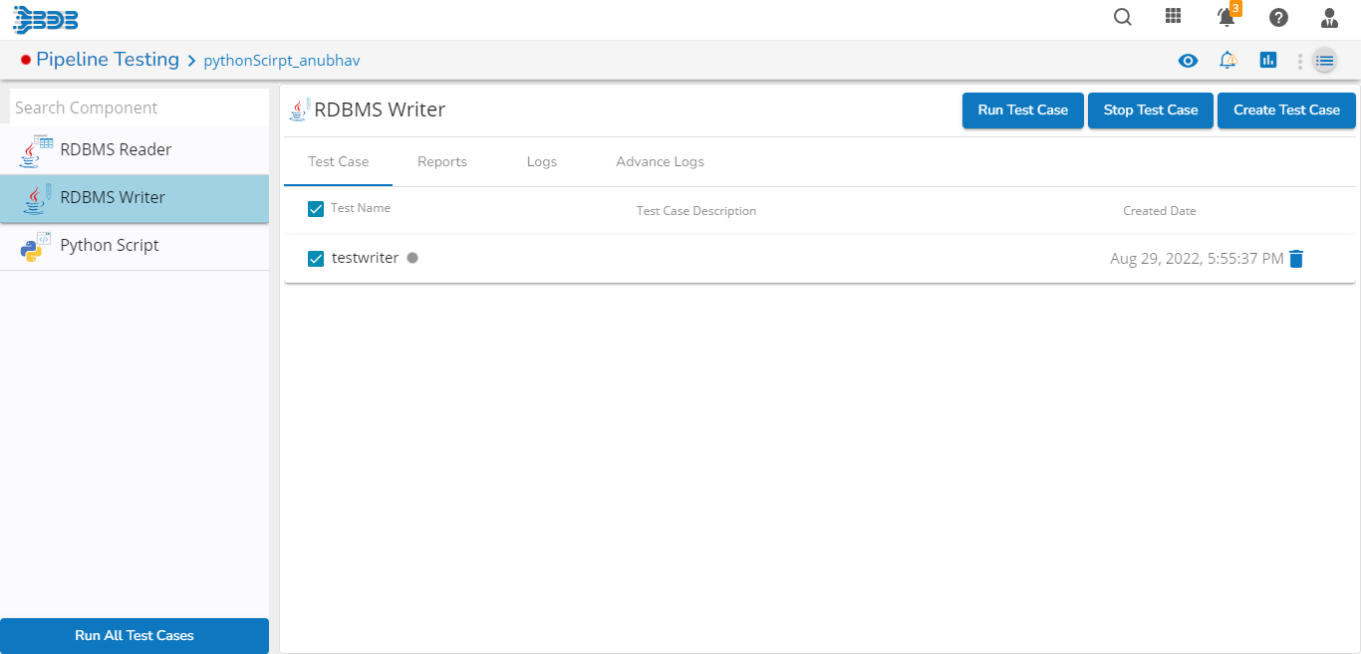
STEP II : As you can see all the components which you want to test will show up on the left hand side of the page.

STEP III : Select the component which you want to test and the following details will show up were you can run the test, stop the test and create different test cases.

STEP IV : Initally to create a test case you need to fill the following details as shown below
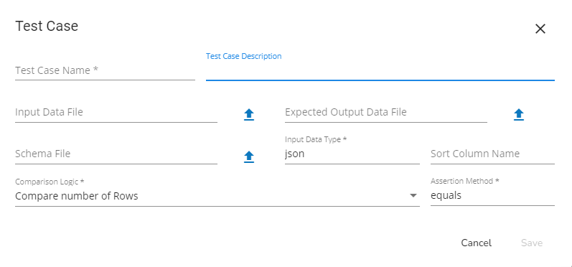
STEP V : After filling all the details you can run the test case and check if the component is performing as per your requirement or not and can verify the same manually also.

STEP VI : After the completion of test case the result will be shown in the report session as shown below:

