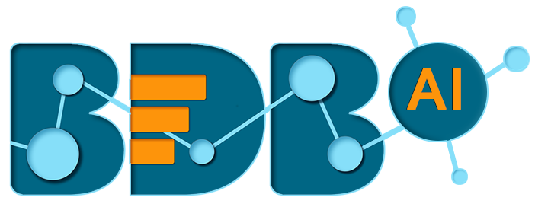
AI, Data Science & Advanced Analytics Platform
Unique Disruptive Platform by Ex-SAP BO R&D Team
One Platform, End to End Solution
Removes industry pain points
Leads to exponential benefits realization

BDB Business Story –
High Level Introduction

BDB Business Story-
BDB Business Story is a user-centric Self-service BI module allowing business users to create, modify, and share interactive data insights through intuitive visuals.
BDB Business Story is a drag and drop based a View and build analytical visual reports within a few minutes and consume data insights instantly. One has complete control over branding, styling, and personalizing the visuals. You can also apply click-based interaction between multiple charts to generate comparative insights across your data.

High-Level Feature Summary of BDB Data Centre
- Business user focused visualization module which lets user create analytical report in minutes.
- This module doesn’t require any statistics / data scientist skills. Any individuals without being heavily trained on analysis can use this module to generate data insights
- Fully customizable module which lets you set up properties, filters, colors, chart types and many other attributes.
- BDB business story has ‘BDB Data Insights’ feature which generates automatic data insights around your data in a single click. This helps user to analyze what possible insights can be generated.
- BDB business story is integrated with AI based data search which is a very powerful data search feature. It helps in exploring data up to any granularity by searching through heaps of data through its NLP capabilities.
- Such business story can be accessed / created / shared through BDB mobile apps (available iOS & android)
- Integration with R for Predictive Insights -Get enhanced visualization using the R Scripting component that brings predictive insights into your business data

Deep-Dive into Features

BDB Business Story Console
BDB business story is the easiest way for a business user to create instant visualizations. It lists down the dimensions and measure of data store which can be dragged and dropped to create data insights

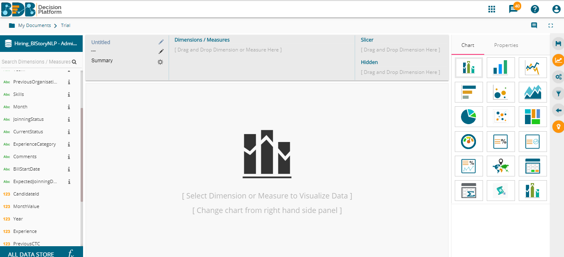

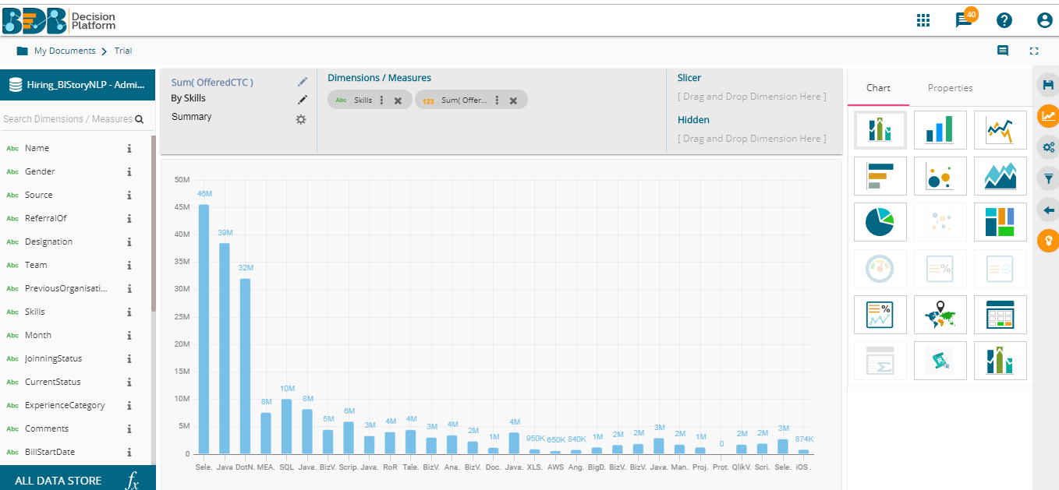

For any views, one can choose different chart types-
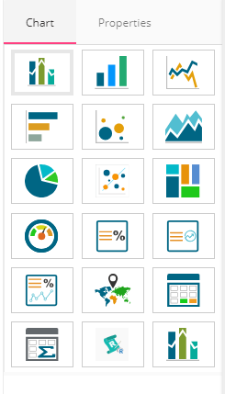
And customized the view by applying various customizations from property panel (property panel options depend on the chosen chart type)
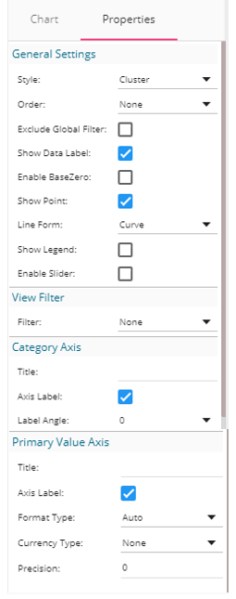

In addition to it, there are various other features –
- Interactions – This feature enables users to select multiple views of the storyboard to filter based on a specific view. By default, on a single click, all the views permitted for interactions get filtered.
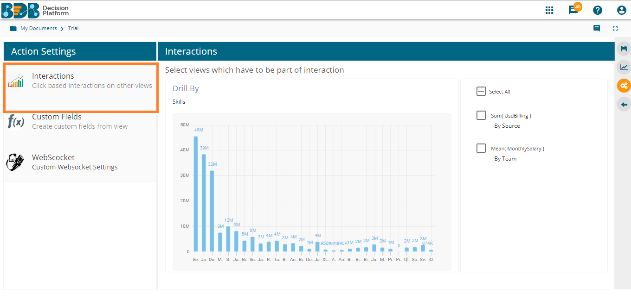

- WebSocket - The WebSocket option under ‘ACTIONS’ is provided to refresh the story when an external event occurs. Users can achieve this by configuring a WebSocket. The WebSocket Configuration contains a WebSocket IP and a message.
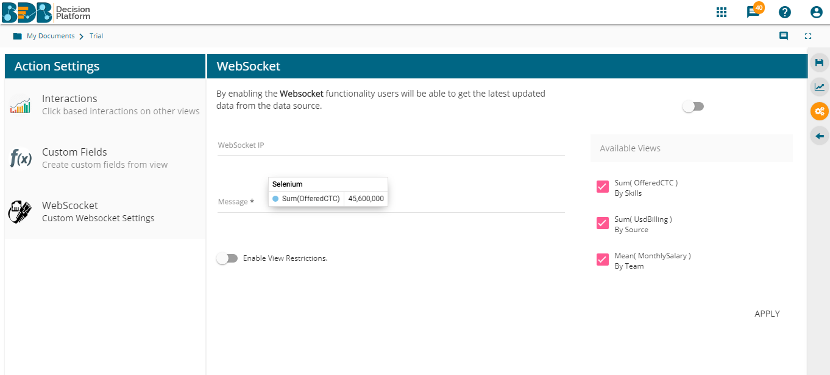

Business Story View
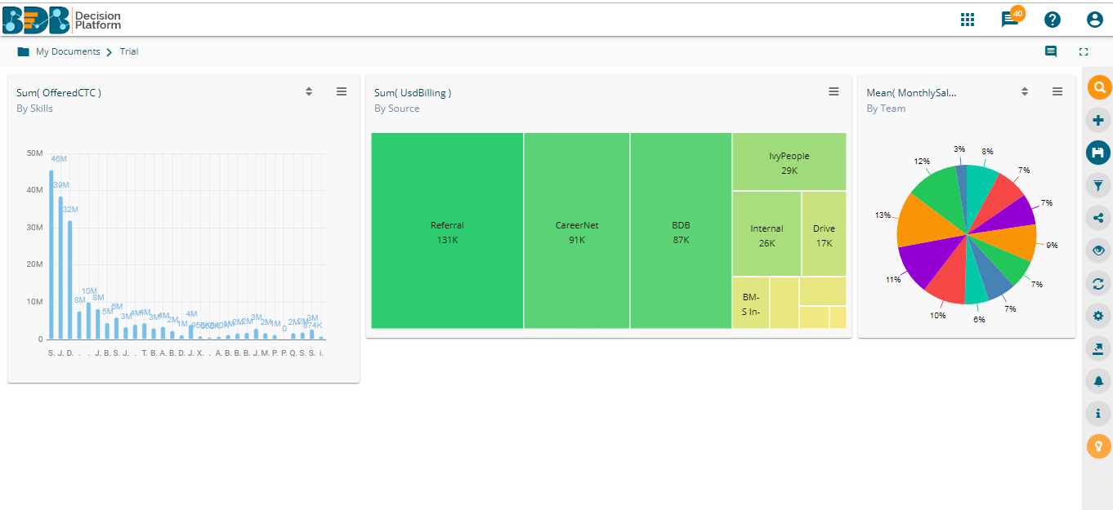

Once multiple views are created, users can leverage many other features listed below

- Filters – One can apply filters on various levels of the view. Available filters are
  - View Filter
  - Local Filter
  - Global Filter
- Share Option – One can share the business story view with many users and user groups
- Refresh Views – To refresh the business story for updates
- Change Theme- Apply various themes like Default, Dark & Moon
- Export – Export the business story in CSV, XLSV, PDF & PPT
- Alert Centre – Create and generate alerts on basis of threshold values
- Start Tour – Gives a quick tour of all features and functionalities of BDB business story

BDB Data Insights
BDB Data Insights feature in BDB Business Story generates automated data insights in a single click. As soon as the data store is ready, one can generate possible visualizations & KPIs automatically related to data fields which makes it convenient for any business user, data analyst, data scientist to unearth instant insights without wasting countless hours of manual data analysis.
Machine Learning Based Insights
BDB Data Insights is based on machine learning unsupervised algorithms that find the correlation between data fields and uncover hidden insights. It automatically identifies the list of key data fields and provides basic insights around it.
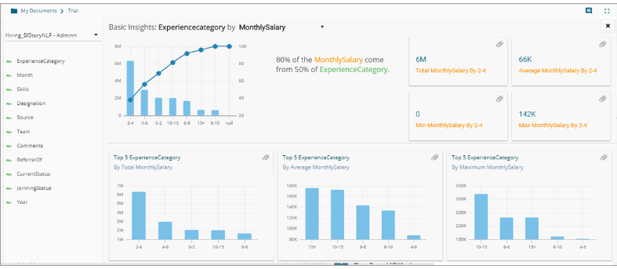

BDB AI based Data Search

BDB’s business story is equipped with AI based data search so that you can explore your data anywhere anytime on any device using everyday language. Enter your data query in the search bar or use voice-assistance to get actionable insights out of your accumulated business data.
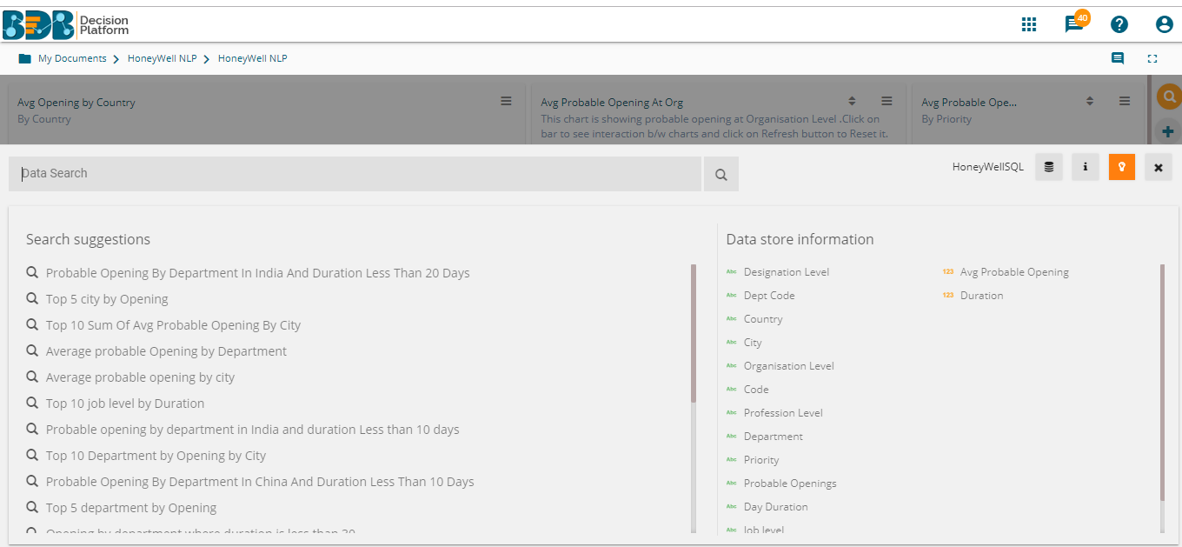
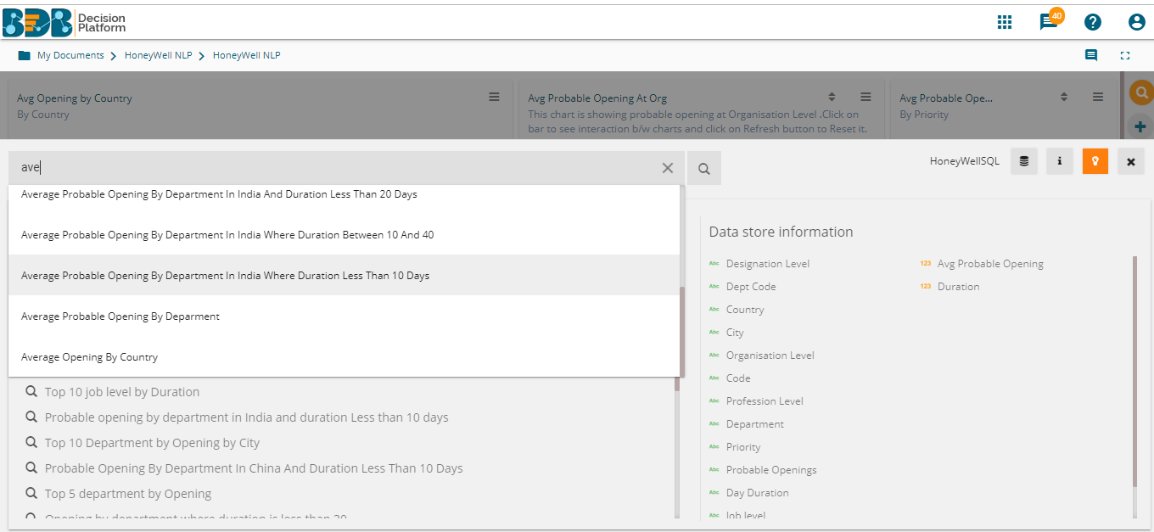
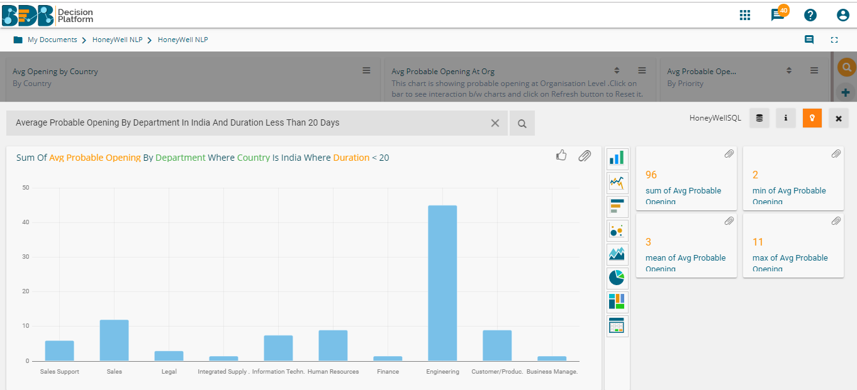

Our NLP based AI-based voice assistance on mobile devices lets you drill deeper into your data and create a complete visual report just with Voice based queries.
